

IBE INTERMOBILITY FUTURE WAYS 2026
THE EUROPEAN HUB FOR SHARED MOBILITY RETURNS TO RIMINI FROM 24th TO 26th NOVEMBER
- The National Conference on Sharing Mobility and the presentation of the Future Ways Report confirmed at the Italian Exhibition Group event
- For the first time in Italy, the “Bus of the Year 2027 – Intercity Edition” awards ceremony
- New agreement with EIT Urban Mobility, an initiative of the European Institute of Innovation and Technology, to accelerate innovation in sustainable urban mobility
Rimini, 27th May, 2026 – IBE INTERMOBILITY Future Ways, the biennial event by IEG – Italian Exhibition Group dedicated to shared mobility, returns to Rimini. The event is organized with the support of the Foundation for Sustainable Development, ASSTRA and AN.BTI Confcommercio, and with the technical support of the Sharing Mobility Observatory and EIT Urban Mobility. The event will take place from 24th to 26th November 2026, at the Rimini Expo Centre, with a program that confirms and enhances IBE’s position as a key reference point in the Mediterranean area for operators, institutions, manufacturers and innovators across Europe.
THE CONFERENCE AND TRAINING PROGRAM OF IBE 2026
The National Conference for the presentation of the Future Ways Report will return, serving as a tool for analysis and strategic guidance on the evolution of shared mobility services in Italy and Europe. Also returning is the National Sharing Mobility Report, now in its tenth edition and curated by the National Sharing Mobility Observatory. These two events confirm IBE’s role not only as an exhibition platform but also as a hub for strategic thinking.
Additionally, the twentieth “Sustainable Mobility in Italy Report: Survey of the Top 50 Cities” by Euromobility will be presented. This study assesses urban mobility in 50 Italian cities, measuring indicators such as motorization rates, public transport, sharing mobility and air quality.
The program will include workshops and in-depth sessions such as the Second report on transport poverty, involving the Transport Poverty Lab community. A dedicated focus will explore the evolution of mobility in China and the models that have reshaped public transport in recent years.
Key topics will include digitalization of public transport services, the central role of buses in future mobility, fleet renewal and management (Bus 2.0), energy transition, including technological risks and opportunities such as real-time monitoring, new tap-and-go payment systems.
There will also be a focus on public mobility in rural and inner areas, highlighting demand-responsive transport (DRT), integration between scheduled and on-demand services and the role of the third sector.
The Masterclass curated by Blue Eggs will return, applying innovative socio-semiotic analysis based on Deep Trend® to the field of new urban mobility.
As tradition dictates, test drives on the road will also be available: throughout the event, manufacturers will provide vehicles to the professional community, allowing both driving tests and passenger experiences.

BUS OF THE YEAR 2027 – INTERCITY EDITION: FOR THE FIRST TIME IN ITALY
On 24th November, opening day of IBE, Rimini will host for the first time in Italy the “Bus of the Year 2027 – Intercity Edition” awards ceremony, the most prestigious global recognition in the road transport sector.
A jury of specialized journalists from across Europe will attend the exhibition, highlighting the event’s international importance.

A DYNAMIC ECOSYSTEM WITH THE BUS AT ITS CORE
IBE INTERMOBILITY Future Ways confirms itself as the leading trade marketplace for shared mobility, bringing together companies, operators, institutions, decision-makers, and stakeholders from complementary sectors.
The bus — the historic protagonist of the event — stands at the center of the “Shared Mobility Fan,” where local public transport, tourism mobility, sharing services, infomobility, and digital services converge within an exhibition and discussion pathway dedicated to the sector’s evolution.

NEW AGREEMENT WITH EIT URBAN MOBILITY: STRENGTHENING IBE’S INTERNATIONAL DIMENSION
The IEG exhibition strengthens its international profile through a mutual agreement with EIT Urban Mobility, an initiative of the European Institute of Innovation and Technology that connects businesses, institutions and cities to develop sustainable urban mobility solutions. The initial three-year agreement includes collaboration on contents, projects and networking, facilitating access to a qualified European ecosystem and creating new opportunities for startups and industry players.

LORENZO CAGNONI AWARD AND START-UP CALL
The Lorenzo Cagnoni Award, dedicated to the most innovative projects presented by exhibitors, has been confirmed. The Call for Start-ups is also open until August 2026, promoted with the support of qualified partners to give visibility to emerging companies and foster the connection between innovation and market.
Start-ups and innovative SMEs operating in B2B can apply in areas such as e-mobility, soft mobility, software, components, road safety, traffic management systems. All applications must align with the focus areas of IBE Intermobility Future Ways.
Call for Start-up partners include: Foundation for Sustainable Development, ANGI (National Association of Young Innovators), Rimini Technopole, ART-ER (Attractiveness, Research, Territory), EIT Urban Mobility.
Both initiatives will culminate with the awarding of winners during the exhibition.
The full program and exhibitor catalogue will soon be available on the official IBE website: www.expoibe.com
PRESS CONTACT - ITALIAN EXHIBITION GROUP
press office coordinator: Luca Paganin; press office specialist: Mirko Malgieri; media@iegexpo.it

MEDIA ADVISOR
Twister communications group
Valentina Tua | vtua@twistergroup.it | cell. 342 1683535 Monica Cipparrone | mcipparrone@twistergroup.it | cell. 349 2814894 Andrea Franceschi | afranceschi@twistergroup.it | cell. 335 7485194

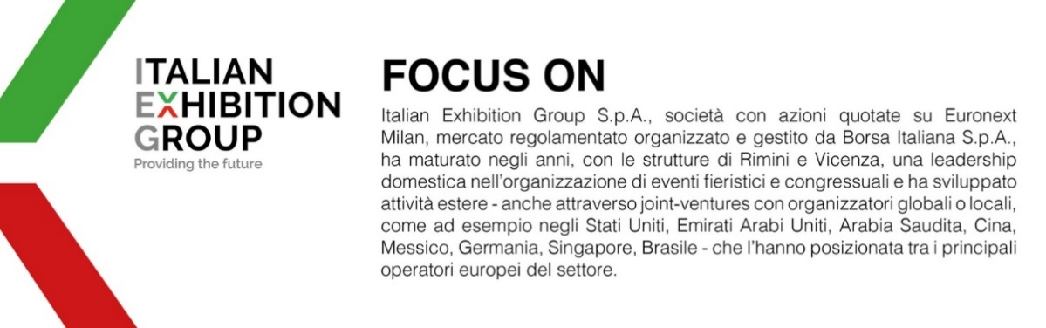

Il presente comunicato stampa contiene elementi previsionali e stime che riflettono le attuali opinioni del management (“forward-looking statements”) specie per quanto riguarda performance gestionali future, realizzazione di investimenti, andamento dei flussi di cassa ed evoluzione della struttura finanziaria. I forward-looking statements hanno per loro natura una componente di rischio ed incertezza perché dipendono dal verificarsi di eventi futuri. I risultati effettivi potranno differire anche in misura significativa rispetto a quelli annunciati, in relazione a una pluralità di fattori tra cui, a solo titolo esemplificativo: andamento del mercato della ristorazione fuori casa e dei flussi turistici in Italia, andamento del mercato orafo - gioielliero, andamento del mercato della green economy; evoluzione del prezzo delle materie prime; condizioni macroeconomiche generali; fattori geopolitici ed evoluzioni del quadro normativo. Le informazioni contenute nel presente comunicato, inoltre, non pretendono di essere complete, né sono state verificate da terze parti indipendenti. Le proiezioni, le stime e gli obiettivi qui presentati si basano sulle informazioni a disposizione della Società alla data del presente comunicato.

