

Press Release

IBE INTERMOBILITY FUTURE WAYS: THE TWELFTH EDITION IN RIMINI
FOCUSING ON INNOVATION, MOBILITY AND NEW PROFESSIONS

• IBE Intermobility Future Ways returns from 24 to 26 November – the Italian Exhibition Group (IEG) event setting the standard for the future of shared mobility
• A packed programme of events, ranging from analysis of data, trends and growth prospects for the sector to new technological and professional frontiers, with a focus on the role of the Mobility Manager
• Among the awards: the Italian debut of the “Bus of the Year – Intercity Edition”

Rimini, 27th July 2026 – The future of mobility is taking shape at the Rimini exhibition centre with IBE Intermobility Future Ways, the event organised by the Italian Exhibition Group (IEG) which, from 24th to 26th November 2026, will serve as the national meeting point for all key players in the sector. Now in its twelfth edition, IBE is organised with the support of the Foundation for Sustainable Development, ASSTRA, AN.BTI Confcommercio, the Sharing Mobility Observatory and EIT Urban Mobility.

The exhibition area is complemented by a packed programme of conferences and workshops that will focus on innovation, sustainability, the integration of services and new forms of collaboration between the public and private sectors, with a view to creating an interconnected ecosystem tailored to citizens’ needs.

THE SHARED MOBILITY OF THE FUTURE AT THE HEART OF THE DEBATE
There are numerous events on the programme for the Rimini event aimed at shaping the future of the sector, starting with the eagerly awaited presentation of the Future Ways 2026 National Report during the opening plenary session ‘Future Ways: shared mobility in Italy’, organised by the Foundation for Sustainable Development, featuring all the data, trends and growth prospects for the sector.
There will also be a discussion on new forms of flexible transport with the talk “Born to be wild: the prospects for Demand Responsive Transit”, which will analyse the role of on-demand transport in the mobility of the future.
At the end of the first day, for the first time in Italy, the Rimini exhibition centre will host the “Bus of the Year – Intercity Edition” awards ceremony, where an international jury of 25 specialist journalists will recognise excellence in technology, safety, sustainability, comfort and build quality.

FROM TRANSPORT TECHNOLOGY TO FUTURE TRENDS

On the second day of the event, the debate on technology will take centre stage with ‘Back to the Future: the metamorphosis of the bus’, focusing on technological trends in sustainable mobility: from apps for planning, paying and tracking public transport, to solutions for passengers comfort and improving transport services.

There will also be an analysis of how mobility has evolved over the last 20 years in 50 Italian cities, based on the 20th Euromobility Report, alongside the award ceremony for Italy’s most eco-mobile city.

Among the growing trends, the rise of the role of Mobility Manager stands out, forming the focus of a meeting organised by ASSTRA, the Ministry of Infrastructure and Transport and ANCI, on the strategic contribution this role makes to managing travel and achieving sustainability targets.

Finally, following the success of the IBE Driving Experience 2025, Rimini will once again host ‘DEEP TREND® – Interpreting the future of mobility beyond the data’, the masterclass organised in collaboration with Blue Eggs: an exclusive event to anticipate trends over the next three years and support businesses’ strategic decisions.

INNOVATION DISTRICT: A SPACE FOR START-UPS AND IDEAS THAT ARE TRANSFORMING THE SECTOR
Innovation District, the ecosystem dedicated to innovation, returns for this edition of IBE Intermobility Future Ways, which once again serves as a platform bringing together businesses, investors and young talents.
To foster the growth of innovative projects, the Call for Start-Ups is now open. This initiative is promoted by Italian Exhibition Group (IEG) with the support of: the Foundation for Sustainable Development, Rimini Technology Park, ANGI and ART-ER as Main Partners, and EIT Urban Mobility for international development. The deadline for submitting applications is 30th August 2026.
The promotion of projects, products and services is at the heart of the Innovation District. Indeed, the most innovative exhibiting companies will be awarded the ‘Lorenzo Cagnoni Prize for Innovation’, dedicated to the three best projects presented at IBE Intermobility Future Ways, and the ‘Lorenzo Cagnoni Award for Innovative Start-ups’, for the three most innovative start-ups.
The full programme for the Forum will be available shortly on the official IBE website: www.expoibe.com.

PRESS CONTACT - ITALIAN EXHIBITION GROUP
press office coordinator: Luca Paganin; press office specialist: Mirko Malgieri; press office assistant: Julia Andreatta media@iegexpo.it

MEDIA ADVISOR
Twister communications group
Monica Cipparrone | mcipparrone@twistergroup.it | cell. 349 2814894
Patrizia Vallecchi - pvallecchi@twistergroup.it | cell. 335 6334169
Andrea Franceschi | afranceschi@twistergroup.it | cell. 335 7485194

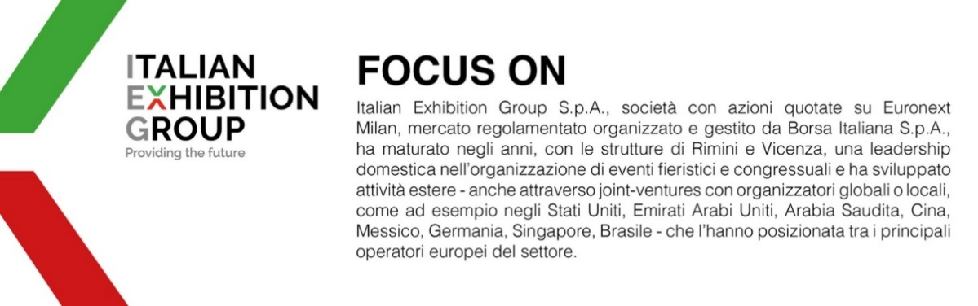

Il presente comunicato stampa contiene elementi previsionali e stime che riflettono le attuali opinioni del management (“forward-looking statements”) specie per quanto riguarda performance gestionali future, realizzazione di investimenti, andamento dei flussi di cassa ed evoluzione della struttura finanziaria. I forward-looking statements hanno per loro natura una componente di rischio ed incertezza perché dipendono dal verificarsi di eventi futuri. I risultati effettivi potranno differire anche in misura significativa rispetto a quelli annunciati, in relazione a una pluralità di fattori tra cui, a solo titolo esemplificativo: andamento del mercato della ristorazione fuori casa e dei flussi turistici in Italia, andamento del mercato orafo - gioielliero, andamento del mercato della green economy; evoluzione del prezzo delle materie prime; condizioni macroeconomiche generali; fattori geopolitici ed evoluzioni del quadro normativo. Le informazioni contenute nel presente comunicato, inoltre, non pretendono di essere complete, né sono state verificate da terze parti indipendenti. Le proiezioni, le stime e gli obiettivi qui presentati si basano sulle informazioni a disposizione della Società alla data del presente comunicato.

